Therapy Department
- Change the header pictures to the following:

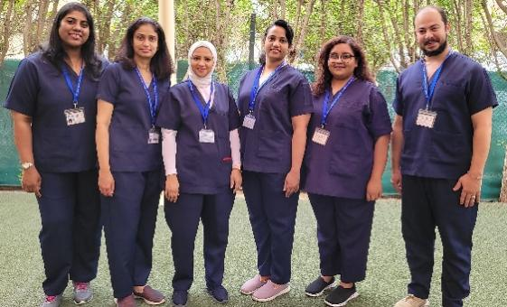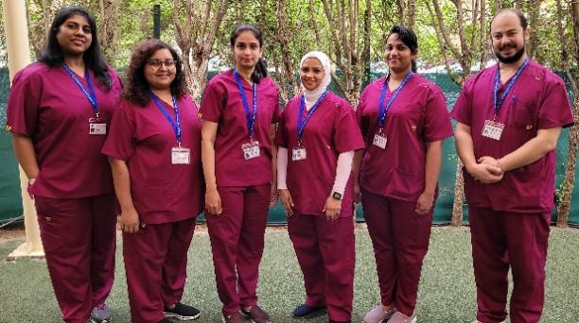
size:1350X360

- Speech Therapy
- Change the header pictures to the following:
 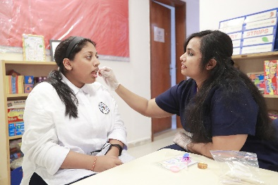 size:1350X360

- Regarding the content under speech and language therapy – add Read more icon.
Speech issues are sometimes caused by neurological damage or impairment from a disease or accident, while others are inherently present from birth.
Read More….
( when they click on read more, they can read the rest of the content)
Speech issues are sometimes caused by neurological damage or impairment from a disease or accident, while others are inherently present from birth.
No matter the reason for the issue, a speech pathologist is trained to handle whatever problems they might be presented with. The Speech Therapists can help students with several oral disorders like:
- Trouble Swallowing (Dysphagia)
- Oro-Motor Skills
- Speech Issues
- Language Issues
- Cognitive-Linguistic Conditions like LD (Learning Disability)
Every child at CCIS has the right to have their communication style recognized, nurtured, and supported, using appropriate means of communication to help them understand their world and to be understood.

- Remove the below

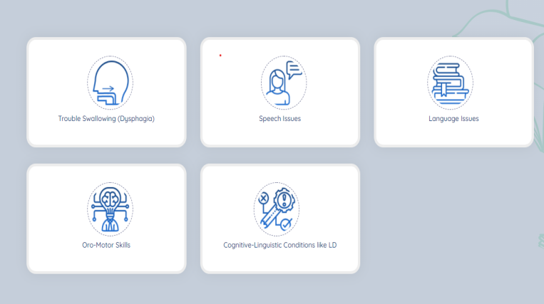

- In this section add the following pictures on the right side as automatic scrolling:
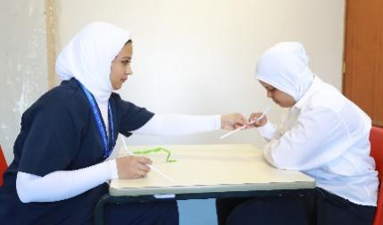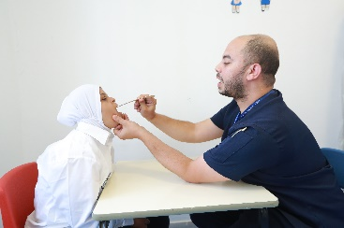

 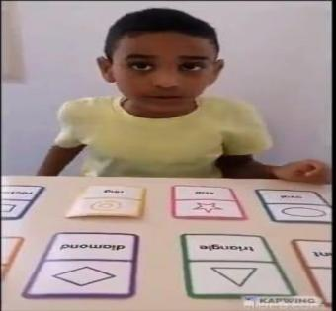 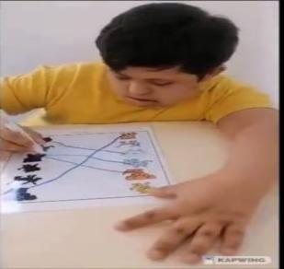size:505X488

- Occupational Therapy:
- Change the header pictures to the following:
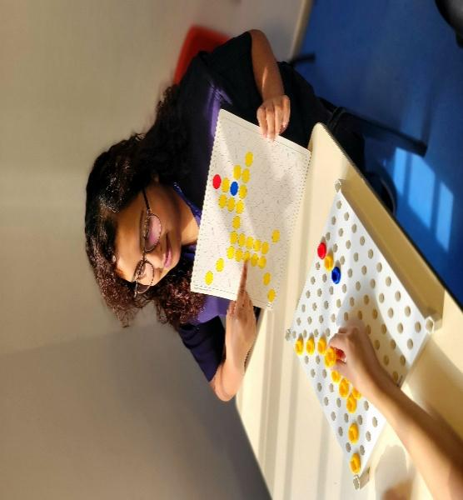 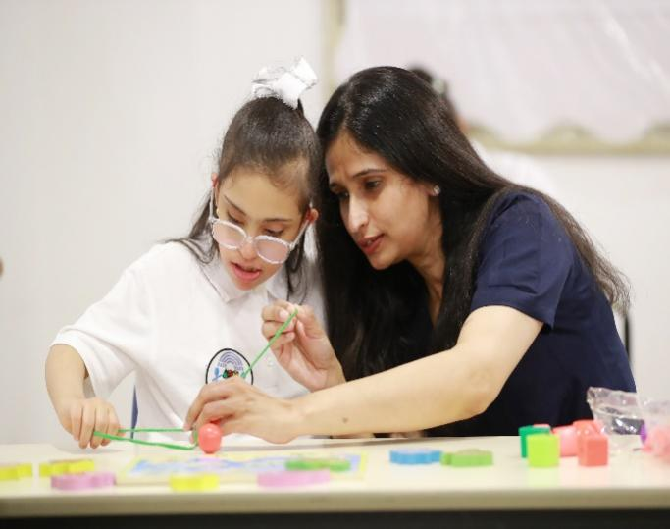size:1350X360

- Regarding the content under Occupational therapy, the content needs to be changed as below :
Occupational Therapy may sound like it involves finding a job or developing work skills, but it actually deals with:
- Fine Motor Skills
- Sensory Integration
- Cognitive Perceptual Skills
- Visual Motor Skills
- Motor Planning
All of above is needed to develop their independence in Play, Academics, and Activities of Daily Living (ADL). The therapists use techniques and routines that may seem like play, but in reality, they are designed to target the areas of delay and difficulty.

- Add Read More…. ( when they click on read more, they can read the rest of the content)
- Add the following pictures as automatic scrolling pictures:

  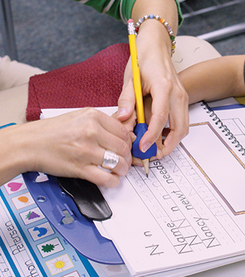size:505X488

- Physical Therapy:

- Header pictures are correct
- Content to be modified as given below and Read more… needs to be added.
Children must meet various physical demands during the school day to be successful from both an educational and a social point of view. They use important motor skills to move within the school premises, sit at a desk through an activity and participate with peers in the playground. The Physical Therapist plays an important role in facilitating the development of these motor skills to allow for optimal participation and socialization for every student. The Primary focus of the Physical Therapist is the rehabilitation and treatment of physical disorders that affect functional ability, general mobility, and potential movement, all of which can improve quality of life for the students. The areas dealt with are:
- Gross Motor Functioning
- Muscle Tone
- Balance
- Joint Range of Motion
- Fundamental Motor Skills
- Endurance and Agility

- Add the following as automatic scrolling pictures:

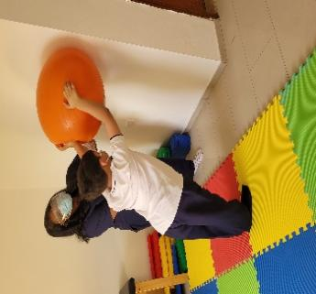 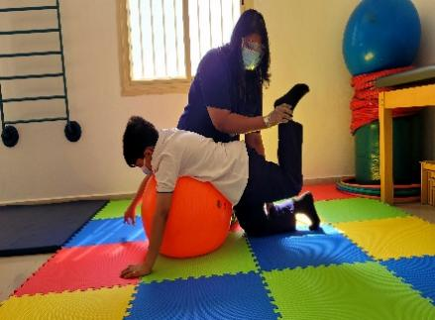 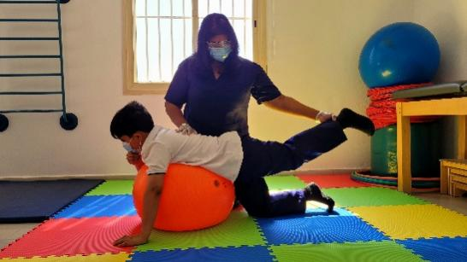size:505X488

- School Psychologist :

- The heading should be changed from Behavioral Therapist to School Psychologist
- The header picture has to be changed to the following:
 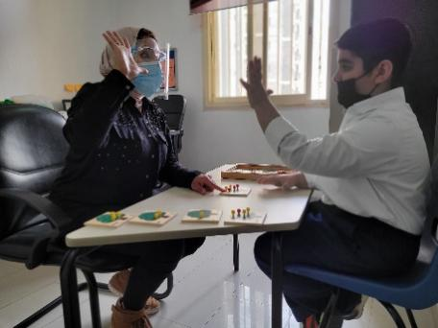size:1350X360

- Add the following picture to the side:
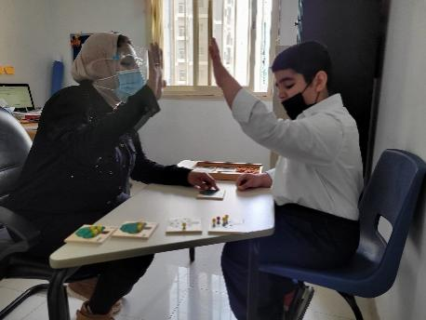 size:505X488
- Add Read more… to the content
The school Psychologist on the team helps children succeed despite emotional or behavioral issues.
Read more…
The school Psychologist on the team helps children succeed despite emotional or behavioral issues. They work to improve the students’ lives across a number of areas enhancing skills required for better academic performance, boosting social functioning, resolving behavioral problems, and supporting emotional health. The psychologist provides a comprehensive assessment to evaluate the student’s intellectual abilities, levels of educational achievement, approaches to learning, and specific strengths and areas of concern. Brief situational counselling is given to students based on their need.

- Social Worker:

- Correct the heading from Social Workers to Social Worker
- Header picture to be changed to the following:


- Regarding the content under Social Worker – add Read more icon.
The school social worker assists in addressing with behavioral concerns, positive behavior support, classroom support…..
Read More..
(when they click on the read more icon, they can read the rest of the content)
Content for social worker:
The school social worker assists in addressing with behavioral concerns, positive behavior support, classroom support, consultation with parents, teachers and administrators as well. They work with students in one-on-one, classroom, or school-wide sessions, in partnership with parents/caregivers, on problems faced in the student’s living situation at home, school and/or community, that affects adjustment in school. They are responsible for maintaining case files, school attendance and reports to track students’ progress and problems.

- School Nurse:
- Correct the heading from Nurses to School Nurse
- Change the header pictures to the following:
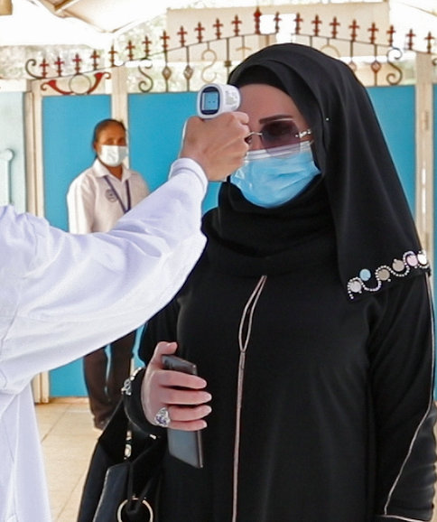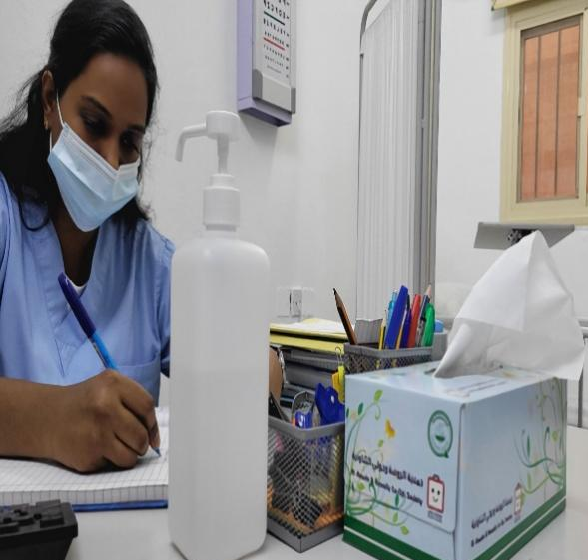

- Add the following as automatic scrolling pictures:

